Want legal forms or need legal help?

* **Go to:** [**http://library.austintexas.gov/**](http://library.austintexas.gov/)
* **Click on rectangle that says Virtual Library**



* **Click on See All Subjects on the left side of the screen**

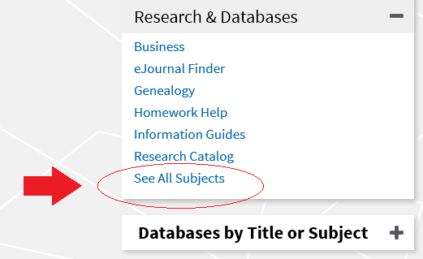

* **Scroll down the list of subjects on the right side of the screen**

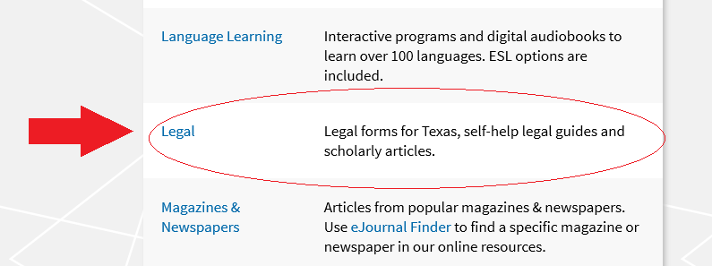

* **Choose what type of legal help you need! Texas Legal Forms can be found there.**

